**WEG’s new compact contactor brings ease-of-installation to the next level**

WEG, a leading global manufacturer of motor and drive technology, has launched a new user-friendly and compact power contactor – the CWB80 – to help electrical engineers and installers save vital space in the cabinet while enhancing ease of installation. With a unit width of just 54 mm and rated currents from 40 to 80 A (three-phase AC, 400 V), the CWB80 is more compact than conventional devices in the same power class (18.5 to 37 kW), proving a versatile solution for a wide range of industrial applications.

To minimise the footprint, WEG has designed the CWB80 so that the power contacts are separated from the auxiliary contacts and control terminals. The mounting sockets for the auxiliary contacts save space and enable toolless mounting of two-pole or four-pole auxiliary contact blocks.

Thanks to a user-friendly modular design, installers can quickly and easily assemble high-performance combination starter modules with short-circuit and overload protection by mating CWB80 power contactors with WEG’s MPW80 motor protection circuit breakers. In situations where short-circuit protection is not required, thermal motor protection relays from the RW67 series can be attached directly.

Various types of snubbers can be plugged in quickly and easily, with no tools. The terminals are easily accessible and are located at different mounting levels according to the contact type.

“Across the industrial market, there is growing demand for cost-effective and versatile automation solutions,” comments Zoltan Schaaf, Manager Low-Voltage Switchgear at WEG. “With this in mind, WEG has developed a solution that helps reduce installation times and costs while reducing the footprint in electrical applications where saving space is very important.”

For switched currents up to 38 A, energy-efficient DC coils enable direct control by a PLC without a supplementary coupling relay. The accessory auxiliary contact blocks and snubbers fit all contactors in the CWB series, simplifying stock-keeping, type selection and configuration.

All WEG’s power contactors in the CWB series are manufactured and tested according to IEC/EN 60947 (DIN VDE 0660) and are UL and CSA approved. Additionally, they are designed to ensure high reliability when switching the higher starting currents of IE3 motors.

For more information visit [www.weg.net/uk](http://www.weg.net/uk).

Follow WEG Europe [Description: Description: Description: Description: Description: Description: Description: Description: Description: Description: Description: Description: Description: Description: Description: Description: Description: Description: Description: Description: Description: Description: Description: Description: Description: Description: Description: Description: Description: Description: Description: Description: Description: Description: Description: Description: Description: Description: Description: Description: cid:image009.jpg@01CE8155.D3CFD760](http://www.twitter.com/WEG_Europe)   [Description: Description: Description: Description: Description: Description: Description: Description: Description: Description: Description: Description: Description: Description: Description: Description: Description: Description: Description: Description: Description: Description: Description: Description: Description: Description: Description: Description: Description: Description: Description: Description: Description: Description: Description: Description: Description: Description: Description: Description: cid:image011.jpg@01CE8155.D3CFD760](https://plus.google.com/103642553426782648112)  [Description: Description: Description: Description: Description: Description: Description: Description: Description: Description: Description: Description: Description: Description: Description: Description: Description: Description: Description: Description: Description: Description: Description: Description: Description: Description: Description: Description: Description: Description: Description: Description: Description: Description: Description: Description: Description: Description: Description: Description: cid:image010.jpg@01CE8155.D3CFD760](http://www.linkedin.com/company/weg-europe)

**Figure captions**

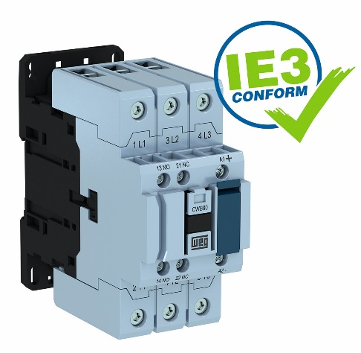

**WEG000709_Image1:** The expanded portfolio of CWB power contactors now provides reliable switching for motors with power ratings from 4 to 37 kW

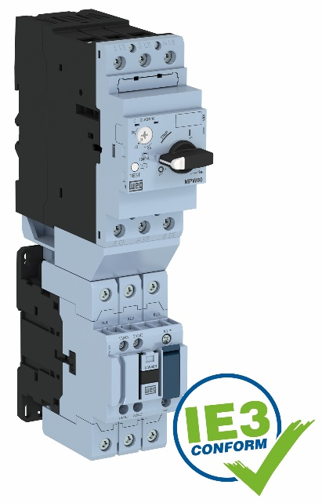

**WEG000709_Image2:** CWB power contactors mate with MPW motor protection circuit breakers to form high-performance combination starter modules

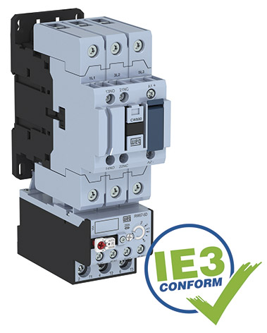

**WEG000709_Image3:** A CWB power contactor combined with an RW-series thermal motor protection relay

## About WEG

WEG is one of the largest global manufacturers of electric equipment, having five main Business Units: Motors, Energy, Transmission and Distribution, Automation and Coatings.  The company employs over 30,000 people worldwide and in 2015 achieved global sales of US$ 3.34 billion, representing success across a wide range of product groups.  These include the latest generation of transformers, LV control gear, generators, gear motors, inverter drive systems, soft starters, LV/MV and HV motors, ATEX-compliant explosion proof motors, smoke extraction motors and full turnkey systems.

Its power generation, transmission and distribution solutions enable those across many industries, especially in the oil & gas, water, power distribution, chemical and petrochemical markets, to operate more efficiently, and to reduce energy usage, carbon emissions and environmental impact. In addition, WEG provides full solutions for renewable energy projects, producing complete wind turbine and solar energy systems.

**Editorial Contact**

Marco Giudici, Technical Publicity  
Tel: +44 (0)1582 390991   
Email: [mgiudici@technical-group.com](mailto:mgiudici@technical-group.com)

**Company Contact**

Marek Lukaszczyk, WEG (UK) Ltd   
Tel: +44(0)1527 513800 Fax: +44(0)1527 513810  
Email:  [wegsales@wegelectricmotors.co.uk](mailto:sclarke@technical-group.com)

## Web: [www.weg.net](http://www.weg.net)/uk