**WEG Motor Scan: A new solution for preventative/ predictive maintenance of electric motors**

***At this year’s ACHEMA trade fair, WEG is exhibiting innovative drive solutions for the process industry – including energy efficient ATEX induction motors with IE4 energy efficiency rating.***

WEG, a leading global manufacturer of motors and drive technology, is unveiling the new WEG Motor Scan at this year’s ACHEMA trade fair in Germany. This innovative technology can be mounted very easily as a retrofit on the motor fins to enable low-cost real time monitoring of electric motors via a smart device App. A maintenance engineer can use the acquired operational data to schedule preventative or predictive maintenance activities. This helps operators to prolong motor life and contributes to higher system availability. At Stand B13 in Hall 9.0, WEG will also be presenting a selection of energy-efficient motors and automation components for the process industry. The highlights include a new generation of explosion-proof induction motors from the W22Xd series, which the drive specialist offers with energy efficiency ratings up to IE4, even though this is not a requirement of the EU Motor Directive. Also new are the ATEX certified geared motors in the WG20 series for zone 2 (gas) or zone 22 (dust).

“In the area of Industry 4.0 and networked drive technology, WEG is focusing on technologies that offer users direct added value at reasonable cost. WEG Motor Scan fulfils exactly these requirements”, says Wilmar Henning, Managing Director of WEG Germany. “What we primarily had in mind when developing Motor Scan was the engineers and technicians who have to monitor the installed motors to ensure constant availability and high process efficiency. Realtime monitoring with Motor Scan prevents problems and outages, thereby avoiding worst-case scenarios. This allows users to reduce costs, improve the profitability of their machines/plants and use resources more efficiently.”

The European Motor Efficiency Regulation (640/2009/EC) stipulates that effective from the 1st of January 2017, new standard induction motors with rated output power from 750 W to 375 kW must conform to at least energy efficiency class IE3, or IE2 with electronic variable speed control. For motors with rated output power from 7.5 to 375 kW, this requirement has been in place since 2015. However, special applications – including explosion-proof motors – are currently exempt from the motor efficiency regulation. "WEG is voluntarily offering the explosion-proof induction motors in the W22Xd series for those power ranges according to 640/2009/EC up to energy efficiency class IE4, using energy efficient induction motor technology. That makes this series, which combines reliable explosion protection with maximum efficiency, currently one of the most energy efficient and attractively priced of its type on the market”, adds Henning.

What’s more, the WG20 geared motors have been updated and certified in accordance with Directive 94/9/EC or 2014/34/EU for zone 2 (gas) or zone 22 (dust). In the past, explosion-proof geared motors were produced by attaching IEC adapters with flange-mount motors (B5) installed on the adapters. Now direct motor mounting improves efficiency and reduces the length of the geared motor, so it needs less installation space. It also shortens delivery times due to the fact that the motors are always available from stock and can quickly be adapted for deployment in the relevant explosion hazard area when an order is received. Subject to compliance with the specified driver parameters, the motors can also be operated with variable speed drives. Explosion-proof WG20 geared motors are presently available with output power from 120 W to 30 kW, and the ongoing extension of the WG20 series to torque ratings up to 18,000 Nm means that explosion-proof geared motors will also be available for the entire power range up to 75 kW in the near future.

Follow WEG on  [](http://www.twitter.com/WEG_Europe)   [](https://plus.google.com/103642553426782648112)  [](http://www.linkedin.com/company/weg-europe)

**Figure captions:**

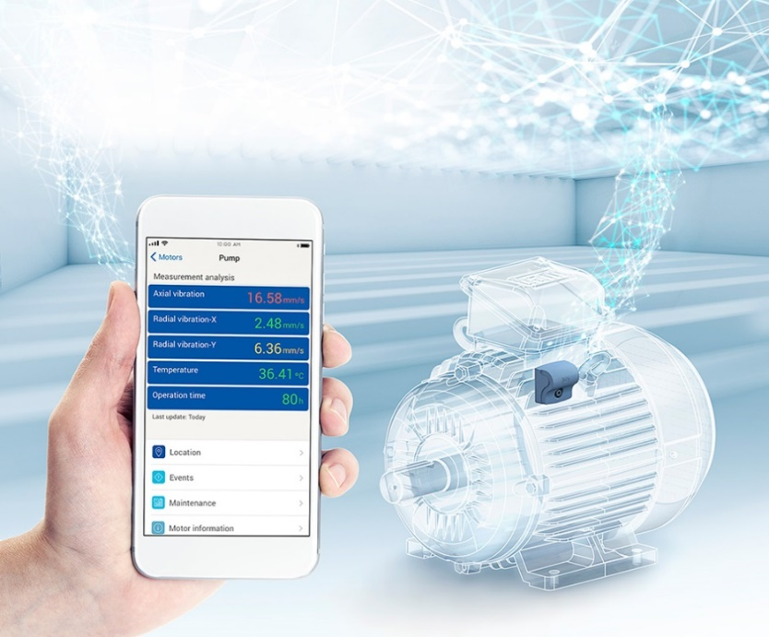

**WEG001392_Figure1:** WEG Motor Scan facilitates cost-effective realtime monitoring of electric motors using a smart device App.

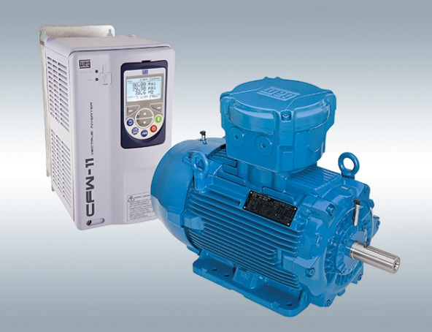

**WEG001392_Figure2:** Special insulation allows the standard explosion-proof motors in the W22Xd series to be operated with variable speed drives at voltages up to 690 V.

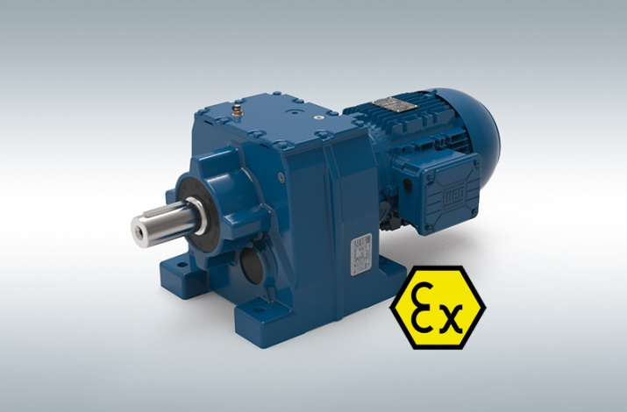

**WEG001392_Figure3:** For ACHEMA, WEG has added ATEX Zone 2 and Zone 22 capability to its WG20 portfolio of helical gear, parallel-shaft and helical bevel gear units.

## About WEG

WEG is one of the largest global manufacturers of electric equipment, having five main Business Units: Motors, Energy, Transmission and Distribution, Automation and Coatings.  The company employs over 30,000 people worldwide and in 2016 achieved global sales of US$ 3.2 billion, representing success across a wide range of product groups.  These include the latest generation of transformers, LV control gear, generators, gear motors, inverter drive systems, soft starters, LV/MV and HV motors, ATEX-compliant explosion proof motors, smoke extraction motors and full turnkey systems.

Its power generation, transmission and distribution solutions enable those across many industries, especially in the oil & gas, water, power distribution, chemical and petrochemical markets, to operate more efficiently, and to reduce energy usage, carbon emissions and environmental impact. In addition, WEG provides full solutions for renewable energy projects, producing complete wind turbine and solar energy systems.

**Editorial Contact**

Ian Jarrett, Technical Publicity  
Tel: +44 (0)1582 390980   
Email: [ijarrett@technical-group.com](mailto:ijarrett@technical-group.com)

**Company Contact**

Marek Lukaszczyk, WEG (UK) Ltd   
Tel: +44(0)1527 513800 Fax: +44(0)1527 513810  
Email:  [wegsales@wegelectricmotors.co.uk](mailto:sclarke@technical-group.com)

Web: [www.weg.net](http://www.weg.net)